February 27, 2014

Minister of Transport Canada

Place de Ville, Tower C

330 Sparks Street

Ottawa, Ontario K1A 0N5

Re: Informational Schedule of Works

To Whom It May Concern:

Enclosed please find ten copies of the report referenced above for the proposed Ambassador Bridge Enhancement Project. The proposed Ambassador Bridge Enhancement Project (ABEP) includes the construction of a new bridge located immediately west of the existing Ambassador Bridge, with four general-purpose lanes and two lanes dedicated to the efficient processing of trucks enrolled in the Free and Secure Trade (FAST) program. The existing span would be maintained, but not for routine use as traffic lanes.

**A. Applicant information**

The new span would be constructed by DIBC in coordination with its commonly-owned Canadian counterpart, The Canadian Transit Company (“CTC”), an Ontario corporation. Both DIBC and CTC are owned by Centra, Inc., a Michigan corporation. As requested, below please find all pertinent information on the proposed project.

Proponent: Name: Canadian Transit Company

Telephone No.: (519) 977-0700  
 Fax No.: (519) 977-1262

Proponent (Contact): Name: Dan Stamper, President

Telephone No.: (586) 819-0455  
 Fax No.: (586) 467-1951

The Ambassador Bridge was constructed pursuant to a 1921 congressional statue that authorized the “American Transit Company, its successors and assigns to construct, maintain, and operate a bridge and approaches thereto across the Detroit River at a point suitable to the interests of navigation, within or near the city limits of Detroit, Wayne County, Michigan, in accordance with the provisions” of the 1906 Bridge Act, provided that the necessary authority for construction was obtained from the Canadian Government and that construction was commenced within three years and completed within seven years. The Detroit International Bridge Company (DIBC) is the assignees of the American Transit Company, having acquired the bridge and the authority to operate it in 1927 pursuant to the 1921 congressional authorization in both Canada and the United States with concurrent and reciprocal legislation. The Canadian Transit Company is a subsidiary of the DIBC.

**B. Description of the Structure**

The proposed project consists of the construction and operation of a new international bridge across the Detroit River parallel to the existing Ambassador Bridge and expansion of the Windsor Plaza (“Project”). The new bridge will provide six lanes of travel, three in each direction, and will tie into the inspection plazas on both sides of the Bridge. One lane in each direction will be dedicated to low-risk commercial traffic participating in the FAST program operated by customs authorities of the United States and Canada. The inside lanes would be for automobiles and other commercial traffic to the tolls and primary customs with flexibility preserved for all types of vehicular operations. The use of the center lanes would depend on the traffic needs of the moment and could be for both trucks and cars or trucks only depending on the traffic mix at any given time.

The existing Ambassador Bridge is a suspension bridge that spans 2,743 metres (9,000 feet) in length, with 564 metres (1,850 feet) over the Detroit River. The height of the two towers is 111 metres (363 feet) tall. The vertical clearance of the bridge structure is 49.55 metres (162.57 feet) over the center of the Detroit River. The structure consists of a 17 metre (55 feet) deck, including four highway lanes of traffic, with two lanes traversing northbound and two lanes traversing southbound. The maximum grade of the bridge is 5%. The Ambassador Bridge also contains a sidewalk that is currently not in use. Once the proposed bridge is built, the existing bridge, which is approximately eighty years old, will be closed to general traffic, rehabilitated and used only when the new bridge is unavailable, as well as for official government vehicles, bridge company vehicles and special occasions. In order to ensure redundancy in the corridor, the existing bridge will be rehabilitated when traffic can be relocated to the new span.

The proposed bridge would run roughly parallel to the existing Ambassador Bridge, tying into the existing plazas in both Canada and the United States without the need for modification to their currently approved and permitted configuration. The Canadian Plaza will be expanded to meet the 25-year planning horizon for the facility. The proposed cable-stayed bridge is approximately 2,130 metres (7,000 feet) in length with about 670 metres (2,200 feet) traversing the Detroit River from tower to tower. The bridge will be a minimum of 46 metres (152 feet) in height above the Detroit River, with the same minimal clearance envelope of the existing Ambassador Bridge and have no impacts on navigational clearance requirements of either Canada or the United States. The location of the Canadian tower will be up to 30.5 metres (100 feet) south of the Detroit River, depending on the final design requirements. The United States tower will be situated up to 30.5 metres (100 feet) north of the Detroit River or further inland on property currently controlled by the proponent if necessary. The height of each tower will be approximately 177.6 metres (582 feet) above existing ground level. The total roadway deck width of the bridge between outside barrier walls will be approximately 31 metres (102 feet). The width of the proposed bridge is set to allow transition directly into the connection points in both the United States and Canadian plazas and to provide the necessary safety shoulders that are not present on the existing structure. Each of the six lanes will be 3.6 metres (12 feet) wide. The proposed Project is planned to be wide enough to accommodate two shoulders in each direction. The outside shoulders will be 3.05 metres (10 feet) wide and the inside shoulders 1.2 metres (4 feet) wide resulting in a total median width of 3.05 metres (10 feet). There is no pedestrian sidewalk proposed for the replacement span (see preliminary plans in Appendix A of the attached EIS).

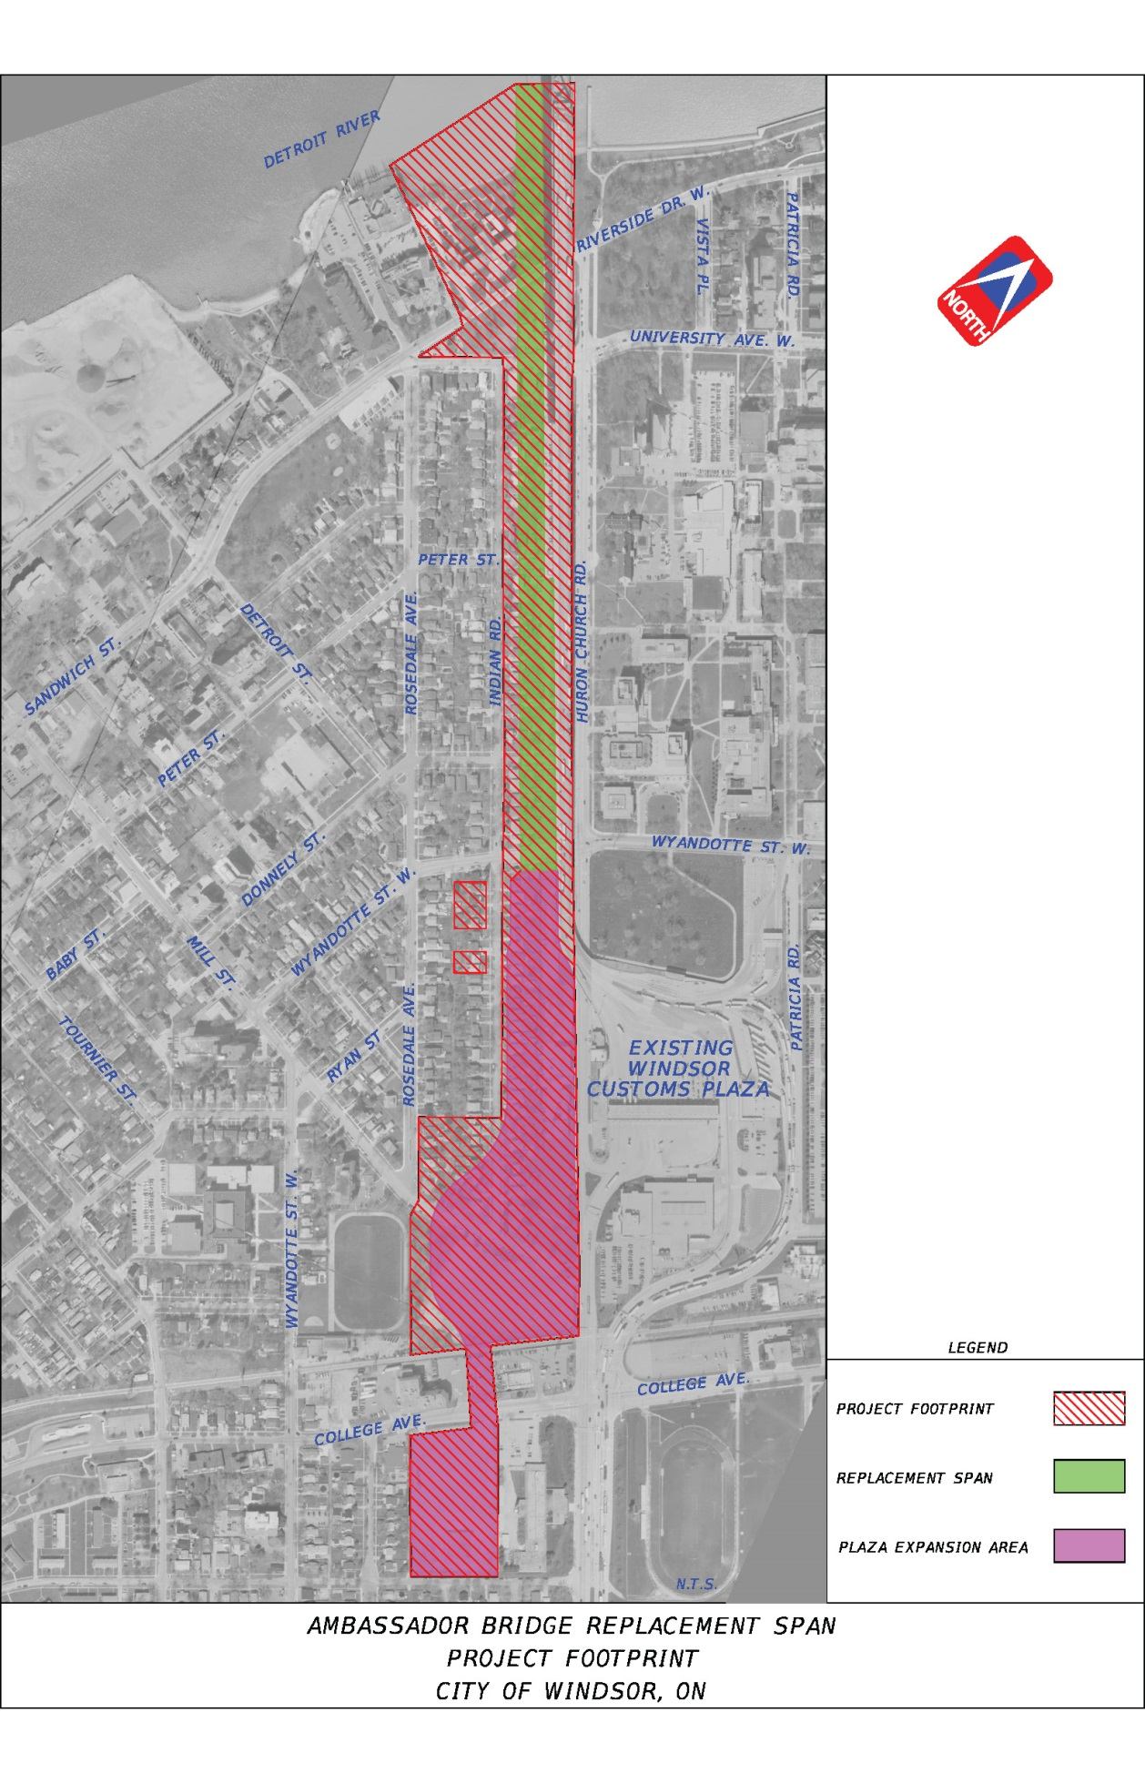

Figure 1: Project Footprint

The project will be divided into three phases with each phase

containing a demolition and a construction component.

**Phase 1:**

The first phase includes the removal of the vacant homes owned

by the CTC in the corridor, the removal of the plaza structure

west of Huron Church Road required for the construction of the

CBSA commercial plaza, the clearing & grubbing of the site

required before construction can begin and the relocation of the

utilities that will need to be moved prior to beginning

construction. See Figure 2 for an overview of the demolition

required during this phase.

As demolition, clearing & grubbing and utility relocation is

Figure 2 Phase 1 Demolition

completed, construction of the stormwater treatment facility,

new CBSA Commercial Plaza to the west of Huron Church Road,

the Maintenance Structure and the Diversion Structure will begin.

Construction of these crucial items in the first phase of

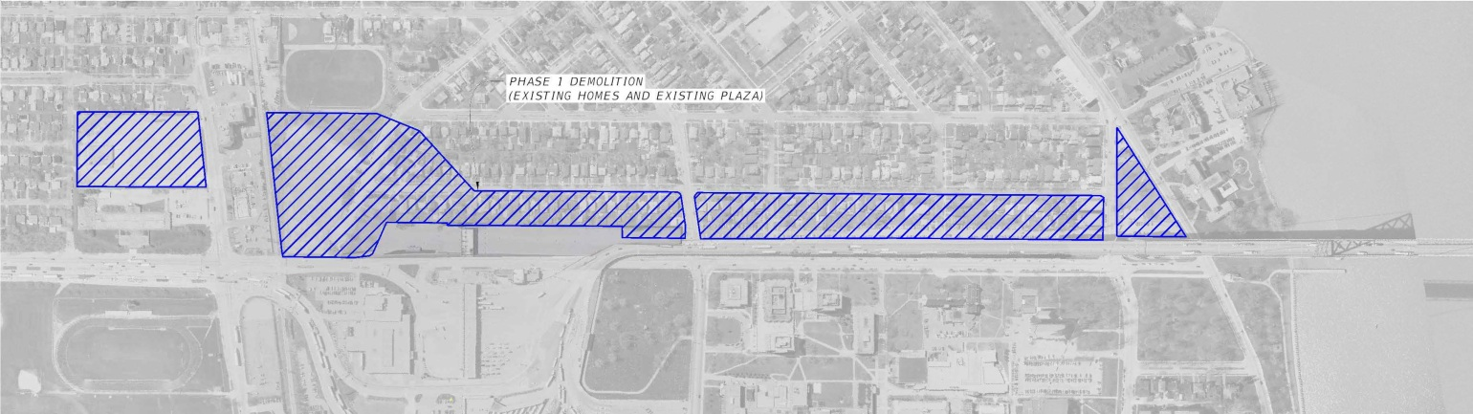construction accomplishes the following key objectives of the TC,

the CBSA and the CTC in the earliest possible timeframe;

* Integration of all CBSA inspection responsibilities into a

single comprehensive operation resulting in a higher level

of security and a more sterile border crossing. All activities

that currently occur at the segregated offsite location

about 4kms to the southwest of the plaza will be

relocated to the on-site expanded plaza and include all

secondary inspection activities and VACIS inspections.

This relocation will immediately improve efficiency and

allow optimization of CBSA resources; both human and

structural.

* Diversion of traffic from the existing Ambassador Bridge

Canadian Approach Spans built over 80 years ago to a new

state of the art Maintenance Structure. Since the existing

bridge has very narrow shoulders and lanes, all

maintenance and repair activities require a reduction

in throughput capacity as routine maintenance activities

occur. While these maintenance and repair activities to

the existing span are not structural in nature since they

generally include concrete spalling, potholing and the

routine maintenance necessary for aging infrastructure,

they do frequently impact the free flow of traffic due to

lane closure requirements. Diversion of the traffic to a

new Maintenance Structure with a 100 year design life

will ensure no traffic impedance for the entire

Ambassador Bridge approach to the Canadian Plaza.

Figure 2: Phase 1 Demolition

* Segregation of trucks from autos as they approach the

plaza thereby greatly improving the processing and

movement of FAST trucks, as well as non-FAST trucks

and autos thru the plaza. Idling of all vehicles is expected

to be dramatically reduced as dedicated lanes for FAST

trucks are opened much earlier than current Ambassador

Bridge infrastructure constraints will allow.

See Figure 3 for a depiction of the construction activity

proposed to take place during the first phase of construction.

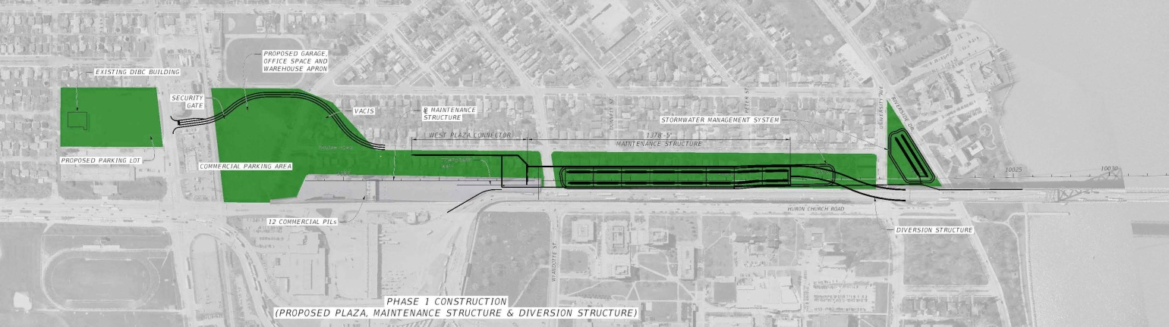

Figure 3: Phase 1 Construction

**Phase 2:**

Figure 3 Phase 1 Construction

After traffic is diverted

to the Maintenance

Structure, a complete

rehabilitation of the

existing approach

spans can be undertaken

without negatively

impacting the free flow

of traffic across the

facility. While traffic

is flowing on the new

Maintenance Structure,

the existing approach

spans to the

Ambassador Bridge can

be removed as shown

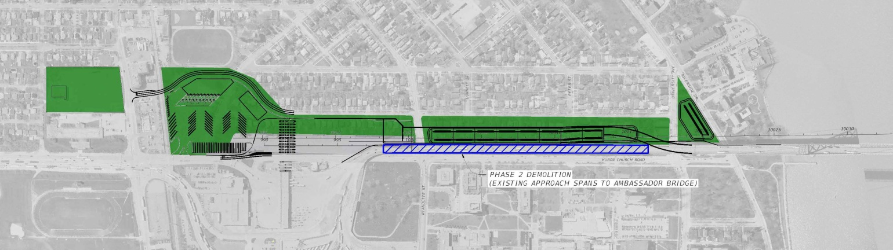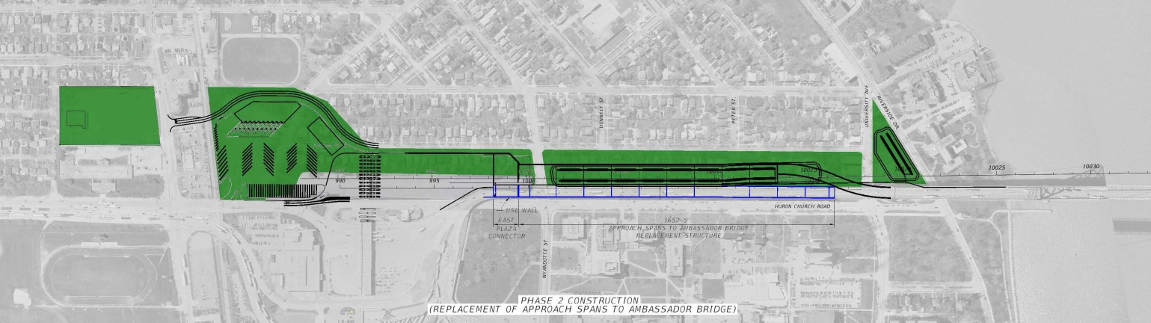in Figure 4.

After the removal of

the existing approach

spans to the

Ambassador Bridge is

complete, the

replacement of these

spans will be

commenced to

complement the newly

constructed Maintenance

Structure as depicted

in Figure 5.

Figure 5: Phase 2 Construction

Figure 4: Phase 2 Demolition

Figure 5: Phase 2 Construction

Figure 4: Phase 2 Demolition

**Phase 3:**

The final phase of the project begins with the removal of the

temporary Diversion Structure constructed during the first

phase of construction that was necessary to guarantee the free

flow of traffic onto the Maintenance Structure and ultimately thru

the entire facility. This removal is depicted in Figure 6.

Figure 6 Phase 3 Demolition

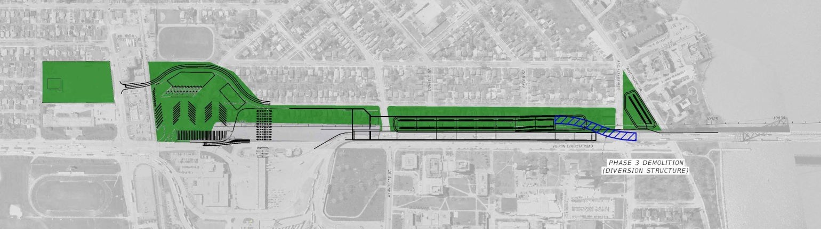

Figure 6: Phase 3 Demolition

With traffic now optimized and shared on the Maintenance and

Replacement Structures after completion of Phase 2, the

second span of the Ambassador Bridge over the Detroit River can

be constructed as shown in Figure 7. While not required for the

operation or scope of the Ambassador Bridge Enhancement Project,

Huron Church Road thru the plaza could be rerouted as shown

below. This relocation of Huron Church Road is an optional

element to the project and will be implemented if the CBSA

requires and is permitted.

Upon completion of the entire Ambassador Bridge Enhancement

Project (including the Commercial Plaza, the Maintenance Structure,

the Replacement Structure and the Second Span) that is

undertaken using this three phase construction strategy, ensures

that traffic will flow at optimal levels at all times during

construction. Furthermore, this methodology for the introduction

of the Ambassador Bridge Enhancement Project ensures the

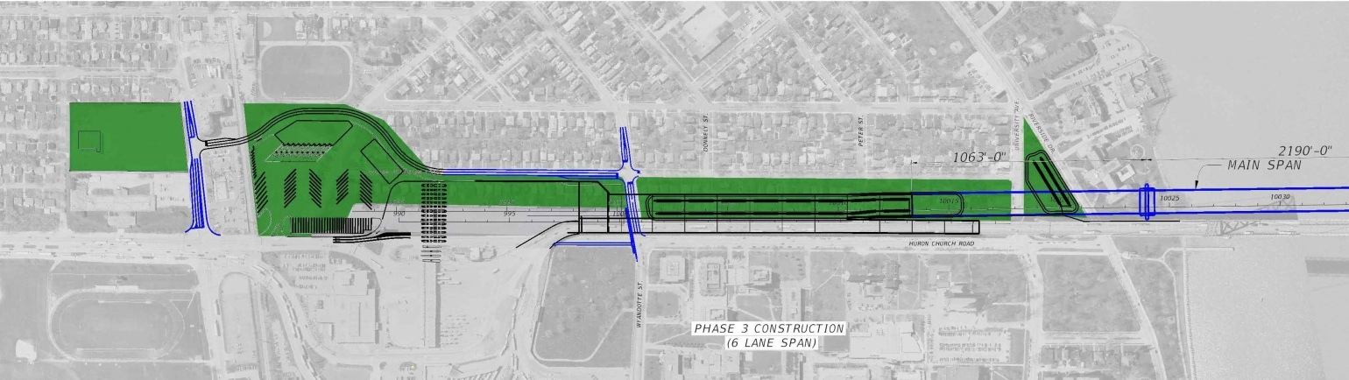continued viability of the Ambassador Bridge corridor indefinitely

while simultaneously achieving its current mission of serving the

needs of the general public and business while routine maintenance

and construction activities occur.

Upon the completion of the final phase of the Ambassador Bridge

Enhancement Project, the existing Ambassador Bridge will be held in

reserve and used as a redundant resource and for operational

vehicles, emergency traffic and approved public events.

**C. Purpose and Need for Alteration**

The Ambassador Bridge corridor not only serves the transportation

needs of the City of Windsor and the City of Detroit, it serves as a

major north-south link between the Province of Ontario and the

State of Michigan, and the crucial trade link between Canada and

the United States. The Ambassador Bridge corridor connects

southern Ontario to the U.S. Interstate Highway network.

The continued operation of the Ambassador Bridge corridor is critical

to the flow of international trade between Canada and the United

States, and connects Canada’s road network with the U.S. interstate

highway system. More than one-quarter of Canada – United

States surface trade crosses the border in the Detroit area and the

majority of this trade is transported by trucks.

Figure 7: Phase 3 Construction

The six-lane, cable-stayed design of the proposed replacement span allows for the efficient and smooth flow of vehicles across the Ambassador Bridge corridor. The proposed FAST/NEXUS lanes along with freer flow of traffic offered by the proposed replacement span will reduce travel time significantly at the Ambassador Bridge corridor. This, in turn, will contribute to the fulfillment of the Federal, Provincial and City’s objective to foster and promote economic development growth.

The purpose of the Project is to:

* Improve the structure to facilitate the movement of vehicles and ensure the continued free flow of goods between Canada and the United States;
* Upgrade efficiency through the provision of FAST/NEXUS lanes;
* Meet current highway standards; and
* Preserve the existing Ambassador Bridge structure.

Improved Structure

The existing Ambassador Bridge continues to be well maintained and is proven to be structurally sound. However, the age of the Ambassador Bridge is eighty-five years old and is increasingly requiring substantial maintenance, especially on the Canadian approach spans to the Ambassador Bridge main span. The continual maintenance undertaken by the CTC ensures that the Ambassador Bridge remains in operable condition for the commercial and passenger traffic. Maintenance is becoming increasingly difficult and often requires the closure of one lane which reduces the Ambassador Bridge to three lanes and slows the free flow of traffic. The replacement span will provide a six lane crossing, including two lanes dedicated to FAST/NEXUS, and ensure the consistent movement of vehicles across the border. Upon completion of all or a part of the project and the relocation of the traffic, the existing bridge will then be rehabilitated to serve as a redundant resource to ensure the most efficient operation of the facility.

More Efficient Border Crossing Programs

The Canadian Border Services Agency (“CBSA”) has developed two programs in collaboration with its American counterparts; FAST and NEXUS. The Free and Secure Trade (FAST) program is a joint Canada-United States initiative involving the CBSA and United States Customs and Border Protection (CBP).

The Free and Secure Trade (FAST) program is a joint Canada-United States initiative involving the Canada Border Services Agency and the United States Customs and Border Protection (CBP). FAST supports moving pre-approved eligible goods across the border quickly and verifying trade compliance away from the border. It is a commercial process offered to pre-approved importers, carriers, and registered drivers. Shipments for approved companies, transported by approved carriers using registered drivers, will be cleared into either country with greater speed and certainty, and at a reduced cost of compliance.

FAST, which is based on sound risk management techniques, focuses on greater speed and certainty at the border and reduces the cost of compliance by:

* Reducing the information requirements for customs/border clearance;
* Eliminating the need for importers to transmit data for each transaction;
* Dedicating lanes for FAST clearances;
* Reducing the rate of border examinations;
* Verifying trade compliance away from the border; and
* Streamlining accounting and payment processes for all goods imported by approved importers (in Canada only).

NEXUS is designed to expedite the border clearance process for low-risk, pre-approved travelers into Canada and the United States. The CBSA and CBP are cooperating in this joint venture to simplify border crossings for members, while enhancing security.

To become a member in this program, you must:

* Submit an application and go through a registration process;
* Satisfy the eligibility criteria;
* Be admissible in Canada and the United States; and
* Pass risk assessments by both countries.

The FAST and NEXUS programs are designed to facilitate and expedite the movement of low risk commercial goods and travelers across the border.

Without the ability to dedicate a FAST and NEXUS lane on the existing Ambassador Bridge, trucks participating in these pre-clearance programs are forced to wait in line behind the non-participating trucks and other vehicles to reach the customs’ inspection station. The inability to provide a dedicated FAST and NEXUS lane significantly reduces the efficiency of these programs. The proposed replacement span would considerably improve the flow of commercial goods and passenger traffic by allowing the anticipated benefits of the FAST/NEXUS programs to be achieved. Both the Canadian and American customs agencies have requested that the replacement span include a dedicated FAST/NEXUS lane in each direction.

Improved Safety Features

As an eighty-five year old structure, the existing Ambassador Bridge does not reflect modern highway standards. Modern standards dictate that highways be constructed with lanes that are 3.6 metres (12 feet) wide and provide safety shoulders. The existing Ambassador Bridge as constructed in the 1920’s, has 3.0 and 3.35 metre wide lanes (10 and 11 feet) and has minimal safety shoulders. The lack of safety shoulders on the Ambassador Bridge causes significant disruptions in the flow of traffic when a vehicle breaks down or an accident occurs.

The replacement span is proposed to be constructed with safety shoulders on both sides of the outer travel lanes. The travel lanes proposed on the replacement span will be 3.6 metres (12 feet) in width and meet current highway design standards.

Preserve the Ambassador Bridge

The Ambassador Bridge will be preserved and is listed as a heritage structure by the Ontario Ministry of Culture and eligible for listing on the United States Register of Historic Places.

As the maintenance structure and ultimately the replacement span become operational, the existing approach spans to the Ambassador Bridge will be taken out of service to be rehabilitated. This will then allow the entire existing Ambassador Bridge and approach spans to be made available as a redundant resource for operational vehicles and emergency situations or approved public events. The redundancy will ensure that the Ambassador Bridge corridor continues to function in its role as a vital border crossing for Canada and the United States and remains functional in all types of situations.

**D. Traffic Information**

One purpose of the ABEP is to upgrade the existing crossing to meet current regulatory standards for lane and shoulder widths and to include FAST lanes on the new structure at the request of the U.S. and Canadian governments. Recent traffic studies have been completed for the Detroit River International Crossing Study (DRIC), the bi-national study for a new crossing over the Detroit River. The DRIC Study participants include the Transport Canada, Ontario Ministry of Transportation, Federal Highway Administration, and the Michigan Department of Transportation. Numerous traffic reports have been posted on the DRIC website at <http://www.partnershipborderstudy.com/>. The first report, “Detroit River International Crossing Study Travel Demand Forecasts” was completed in September 2005 and established the total cross border unconstrained travel demand. Since these are the demand volumes, they represent the upper bound on the traffic projections. The projected traffic volumes in the study are based on the estimated demand for travel across the river and are not constrained. These volumes were then used to assess future capacity needs in the region.

The total 2030 cross border traffic demand in the region was found to be 35,055,000 by this study and is shown in Figure 10 along with the projected distribution and profile of that total volume distributed among the existing crossings in the region.

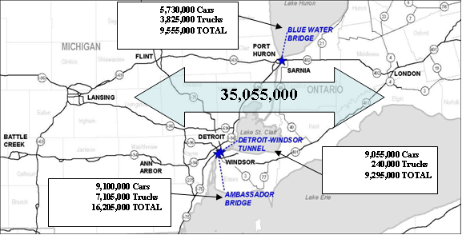

Figure 1: Projected Regional Traffic in 2030

The proponent has conducted its own traffic and investment grade study and concluded that these volumes are higher than could reasonably be anticipated. However, for planning purposes, the higher, unconstrained and upper bound DRIC traffic volumes were used in assessing the environmental impacts for the project to ensure sufficient mitigation is provided should the DRIC project never be constructed. As a result, the peak hour traffic volumes used for planning purposes of the ABEP are shown in Table 1 below.

Table 1: Year 2030 Peak Hour Volumes at Ambassador Bridge based on DRIC Level 3 Report



* 1 Truck = 2.5 PCE (Passenger Car Equivalents)

**E. Project Schedule**

The proponent intends to divide the project into the following five primary elements;

1. Demolition of existing structures along with clearing & grubbing to create space for the construction of the ABEP and the landscape buffer. Estimated time to complete = 3 months from approval.
2. Construction of the Maintenance Structure alongside the existing bridge to allow the full rehabilitation of the existing approach spans. This Maintenance Structure will become the approach spans portion of the main river crossing for the ABEP. Estimated time to complete = 18 to 24 months from approval including final design.
3. Relocation of the offsite commercial inspection facility to an onsite location on property already owned by the proponent on the west side of the plaza. Estimated time to complete = 18 to 24 months from approval including final design.
4. Relocation of Huron Church Road to the perimeter of the plaza rather than breaching the plaza itself. Estimated time to complete = 4 months after direction by CBSA including final design.
5. Construction of the river crossing. Estimated time to complete = 48 months from approval including final design.

The actual site and conditions and operation parameters allow elements two thru five to be constructed simultaneously or in any order. That is, none of these elements are contingent or dependent upon the other being constructed. However, the proponent intends to construct each of these elements in the order described in detail in Section B or in the order that they are approved. The environmental assessment conducted for the project made the conservative assumption that simultaneous construction would occur so phasing the project as proposed will only serve to reduce environmental impacts during construction.

**F. Financing and Business Case**

The proposed replacement span is anticipated to cost approximately $400 million dollars. This estimated cost includes the property already acquired along with the construction of the entire replacement span including the linkages into the existing Canadian and United States' plazas and the ultimate plaza expansion.

The bridge will be constructed through private funds.

**G. Insurance**

The DIBC/CTC will extend its current coverage from the existing bridge to include the new span.

**H. Security**

Security will be significantly enhanced by the proposed project. The current offsite commercial customs plaza inspection facilities will be relocated to an on-site location within the sterile area. This will ensure no security breaches occur as commercial vehicles bound for the current off-site secondary inspection facilities transit thru City of Windsor streets while mixing with local traffic before being inspected. The existing local street, Huron Church Road, which currently breaches the existing plaza and comingles local and international traffic on the plaza site, is planned to be closed if directed by CBSA and approved. Avoiding this penetration of the plaza by a local street passing thru the facility in the southbound direction would avoid the potential of co-mingling of international and local traffic and improve the security of the facility, but is not a requirement for the remaining portions of the project. With the new bridge constructed to current standards, including safety shoulders, it will facilitate access for customs authorities and personnel to fully access the facility, even during peak traffic periods. The new bridge will be designed to the state of the art and the higher, more robust standards of today’s design codes.

The CTC has consistently worked with the Canadian Border Services Agency (CBSA) (and its predecessors) in a cooperative manner for more than eighty (80) years to implement security measures and facilities requested by CBSA to operate the Windsor Plaza in an efficient, safe and secure manner. The Ambassador Bridge has discussed the proposed replacement span and plaza expansion with the CBSA to ensure that the needs of CBSA are, and continue to be, met in the future. Security will always remain a concern for the Ambassador Bridge crossing as well as all major infrastructures in Canada. The CBSA personnel permanently stationed at the border crossing will continue to enforce security-related federal requirements.

Recent terrorist acts have heightened security concerns throughout the US, Canada and the world. At all of the existing Detroit River crossings, security procedures and systems have been either upgraded or are in the process of being upgraded. However, all of this work is being carried out at facilities that were never designed to engage intense security measures and facilitate the efficient movement of traffic at the same time. Although these retrofitted security system enhancements are effective, they come with a cost that translates into a general slowing of the cross border movement of goods and materials. Security threats, adverse weather, vehicular accidents and maintenance activities are events that can result in the closure of any bridge, and this contingency has been taken into account in the design of the Enhancement Project. The Proposed Project will meet modern national security needs. The addition of dedicated FAST lanes on the new bridge will allow traffic to move more efficiently while also ensuring proper enforcement of security, immigration and legitimate trade standards.

**I. Consultations for the Environmental Assessment**

Consultation is the process where interested parties are provided an opportunity to contribute to the scoping of the project and the environmental assessment as outlined in section 16(1) (c) of the *Canadian Environmental Assessment Act*. Public consultation also allows for interested parties to contribute local knowledge or expert advice that is useful when conducting the environmental assessment. This public consultation process includes consultation with members of the public, stakeholders, Aboriginals persons and experts.

Consultation with the Public and Stakeholders

The CTC, as part of the environmental assessment process, committed to an extensive public consultation plan. The objective of the public consultation plan was to identify all those groups necessary to ensure a public consultation that includes everyone having an interest in the proposed Project. The goal of the public consultation plan was to heighten public awareness of the proposed Project, gather input from interested parties, while providing the Ambassador Bridge the opportunity to respond to, and resolve the issues raised, in a timely manner in an effort to avoid unnecessary delays in the process while at the same time ensuring all interested parties have an opportunity to comment on the proposed Project. A copy of this Public Consultation Plan is attached in Appendix O of the attached EIS.

Consultation with the public regarding the proposed Project has been ongoing for several years. Representatives of the proposed Project have reached out to the community since 2005 to discuss and review the proposed Project. The comments made from the public during these meetings have been considered and taken into account in finalizing the studies and assessment of the environmental effects of the proposed Project.

The Ambassador Bridge held a series of public information sessions and open houses to discuss and review the proposed Project. At the public information sessions, attendees were greeted, encouraged to ask questions and to provide any comments or ask any questions on the addressed and stamped comment cards provided. Four public information sessions were held from April 16 – 19, 2007. A series of four locations were chosen throughout Windsor and the County to ensure that all members of the public interested in the proposed Project had an opportunity to attend the public information session at a convenient location. The four locations included Essex District High School, St. Francis Elementary School in Sandwich Town, the Royal Canadian Legion on Huron Church Road, and the Caboto Club in the City of Windsor.

At the public information sessions, a presentation was provided and representatives from the proposed Project consulting team and the Ambassador Bridge were available to respond to any issues raised by the public concerning the proposed Project. Appendix Oof the EISpresents a comprehensive list of the questions raised at the public information sessions and the responses provided. Public concerns raised at the public information sessions were considered by the proposed Project study team during the refinement of the recommended plan. Announcements of the sessions were made on radio and published in the local newspapers including the Windsor Star. There were also several advertisements placed in the Windsor Star over the course of the proposed Project to update the public on the progress of the technical studies and to provide information relating to the proposed Project.

The Open House meetings were held over two consecutive evenings at the University of Windsor LeBel Building on June 25 and 26, 2007. The meetings were held to discuss the preliminary results of the technical studies. The preliminary results presented included; air quality, noise and vibration, archaeological, vegetation, wildlife, fish and fish habitat, surface water, groundwater and socioeconomic studies.

All members of the public who provided their contact information to a study team representative or during the public information sessions were sent a letter or an email advising of the date, time and location of the Open House. Announcements of the Open House sessions were made on the local radio station and published in the Saturday edition of the Windsor Star. During the Open House sessions, attendees were greeted and provided with an overview of the presentation, invited to view the displays of the proposed Project and speak with representatives from the Ambassador Bridge study team.

Comment cards were available and provided to those attending the public information and open house sessions. Individuals were encouraged to provide any questions and/or comments on the stamped cards provided. All questions and comments received during the information sessions and public open houses were responded to by the Ambassador Bridge. Copies of these responses are included in Appendix O of the EIS.

During the scoping process and for the purposes of conducting the environmental assessment, numerous stakeholders were contacted and provided with the opportunity to express issues regarding the Project and offering information to assist in the preparation of the technical studies.

Several meetings and information sessions were held with the various municipalities, local chambers of commerce, unions, business improvement areas, community groups and any other interested groups who agreed to meet with the study team representatives. Representatives from the proposed Project contacted over sixty organizations offering to meet. Meetings were held with over twenty-nine different organizations, consisting of all the organizations who agreed to meet. Throughout the entire consultation process, any concerns raised were considered and taken into account by the Study Team.

Upon completion of the reports prepared in support of the Environmental Impact Statement, two open house meetings were held at McKenzie Hall and Ciociaro Club on October 1, 2007 and October 2, 2007 to discuss the final results of the various technical studies and address any remaining concerns expressed by the public. Any concerns raised at the open house meetings were considered and taken into account by the study team and the necessary revisions made to the environmental impact statement.

A meeting was held with the City of Windsor, its representatives and technical consultants on November 15, 2007. More recently, the CTC, along with TC, met with representatives of the City on June 24, 2013 to discuss the final EA and its findings after the City submitted comments on the Draft Environmental Assessment Screening Report and Environmental Impact Statement.

The local Members of Parliament (Brian Masse, Jeff Watson, and Joe Comartin) and the local Members of Provincial Parliament (Bruce Crozier, the Honourable Sandra Pupatello, and the Honourable Dwight Duncan) were also contacted individually and provided an opportunity to meet and discuss the proposed Project. Two letters, on March 23, 2007 and May 24, 2007, were sent to these individuals requesting a meeting to provide an update and information on the environmental assessment and the proposed Project. Further to the letters, meetings were held with Brian Masse and Joe Comartin, Jeff Watson, Bruce Crozier and the Honourable Sandra Pupatello. The Honourable Dwight Duncan was not available to meet.

All issues raised during public consultation were reviewed and evaluated for their relevance to the environmental assessment for the scope of the proposed Project. This information was considered and taken into account during the preparation of the various technical studies and reports in determining the environmental effects of the proposed Project and the appropriate mitigation measures.

During construction, the CTC has agreed to create a Community Consultation Plan. The Community Consultation Plan will be developed during the design phase of this project and will incorporate a Noise Management Plan. A CTC representative will be accessible at all times and appointed as the community contact to address any questions, concerns or complaints during construction. As part of the Noise Management Plan, CTC will retain an expert to address noise related complaints or concerns and conduct any necessary field work related to noise during construction, when necessary. The Community Consultation Plan will also include at least one public meeting prior to construction and a public website with project information and information on how to comment on the Project.

Consultation with First Nations

Consultation with First Nations is important in assessing any potential environmental effects of the Project on the current use of land and resources for traditional purposes by Aboriginal persons. There are four First Nations that have an interest in the Windsor area. These communities are: Aamjiwnaang, Caldwell, Wyandotte (also known as 'Wyandot'), and Walpole Island First Nations. All of these communities were provided an opportunity to participate in the consultation process. Representatives from the CanAm Indian Friendship Centre of Windsor was also contacted and provided with an opportunity to participate in the consultation process.

Letters were both couriered and faxed to the Chief of each of the First Nation to request a meeting to discuss the proposed Project. Information relating to any traditional knowledge of the area to assist in identifying potential environmental effects and any relevant biophysical and historical information otherwise unavailable was also requested. Copies of these letters are attached as Appendix O of the EIS.

There has also been a Walpole Island consultation initiative. This activity consisted of a presentation to the Walpole Island Heritage Committee, a presentation and meeting with Chief and Council and a public open house meeting held on June 28, 2007 at Walpole Island United Church. Information relating to the Project and the results of any environmental studies were presented at the open house. Feedback sought and obtained during the consultation process is incorporated into the environmental impact statement.

More recently, CTC met with the Walpole Island First Nations (WIFN) on March 22, 2013 and November 1, 2013. The purpose of both meetings was to re-engage the WIFN in the consultation process of the project. Consultants of the WIFN have reviewed the EIS and are currently working with the CTC to resolve outstanding concerns, none of which are significant. Further, the CTC plans to invite the WIFN to be part of a committee during construction to provide information, oversight and comment.

**J. United States Approvals**

**United Stated Coast Guard (USCG)**

The review of the project in the U.S. is being led by the Coast Guard under federal NEPA regulations and Coast Guard NEPA Implementing Instructions. The Coast Guard is a Federal permitting agency utilizing Council on Environmental Quality (CEQ) approved implementing instructions to apply NEPA. The ABEP will require the issuance of a Coast Guard Bridge Permit since the proposed companion bridge will cross a navigable waterway of the United States. By virtue of the permit requirement, the ABEP is a Federal undertaking. The applicant is a private entity committed to using private funds for the proposed project. There will be no federal money expended for this undertaking. The use of private funds, and the Coast Guard Bridge Permit requirement, requires the Coast Guard to assume the duties of lead federal agency for NEPA as well as a federal permitting agency.

The approval of the Environmental Assessment (EA) is required prior to the issuance of the Bridge Permit. The Draft Finding of No Significant Impact (FONSI) has been drafted by the Coast Guard but is not signed. Approval of the FONSI is expected in early 2014 The Bridge Permit application has been submitted to the Coast Guard and approval is expected shortly after the FONSI is signed.

The Draft EA was distributed by the U.S. Coast Guard to the City of Detroit, FHWA, MDOT, International Joint Commission, Michigan Department of Environmental Quality, Michigan Department of Natural Resources (MDNR), Michigan State Historical Preservation Office (SHPO), National Park Service (NPS), Southeast Michigan Council of Governments (SEMCOG), United States Army Corps of Engineers (USACE), United States Customs and Border Protection (CBP), United States Environmental Protection Agency (EPA), United States Fish and Wildlife Services (FWS), United States National Marine Fisheries Service, General Services Administration, U.S. Department of Homeland Security, City of Windsor, Canadian Environmental Assessment Agency, and Transport Canada for review and comment. All of the federal agencies listed above receive copies of all Coast Guard Public Notices. The more significant consultations for this project are described below.

**Department of State (DOS)**

Permission to establish an international corridor and construct a bridge was granted by an Act of Congress on March 4, 1921. DIBC requested the Department of State (DOS) provide a determination of current Presidential Permit requirements at the crossing for the proposed second span. The DOS responded by letter dated August 3, 2005 stating that since DIBC is seeking to expand (or twin) the operation of the existing bridge within an already approved international corridor, a Presidential Permit is not required under Executive Order 11423, as amended. Coordination with DOS is completed with this letter. The August 3, 2005 DOS letter confirms that the IBA72 “should not be construed to adversely affect the rights of those operating bridges previously authorized by Congress to repair, replace, or enlarge existing bridges.” In the case of the Ambassador Bridge, the bridge was permitted and constructed before the promulgation of the IBA72. The Coast Guard expects to amend the current bridge permit to incorporate the second span, if the proposal meets all applicable bridge permitting requirements.

**U.S. Army Corp of Engineers**

The U.S. Army Corp of Engineers (USACE) was provided a copy of the Preliminary Review Permit Application submitted by the proponent in 2004 to review plans to construct a second span adjacent to the existing span at the Ambassador Bridge and was asked for a permit determination by USACE. The Detroit District of the USACE responded by letter dated April 21, 2005 stating that since the project appeared to not involve discharges of dredged and/or fill material in Detroit River or adjacent wetlands, a USACE permit would not be required.

The proponent later submitted a joint application to MDEQ and USACE for construction of an outfall structure in Detroit River connected with the stormwater discharge permit applied for. The USACE authorized the proposed outfall under Nationwide Permit 7 in a letter dated February 28, 2007. All permits and authorizations necessary from the USACE have been obtained and coordination is concluded with this letter. MDEQ ultimately issued a permit dated March 1, 2007 and again on April, 26, 2013. The permit is valid until 2018.

**U.S. Fish and Wildlife Service**

The U.S. Fish and Wildlife Service (USFWS) were provided Coast Guard Public Notices for the *Project Description and Categorical Exclusion Environmental Documentation* in 2006, and for the Draft EA in April 2007. USFWS provided letters in response to both Public Notices. The letters are dated August 29, 2006, and May 31, 2007, respectively.

The August 29, 2006 letter identified one species, the northern riffleshell mussel (*Epioblasma torulosa rangiana*), a federally listed endangered species, may occur in the vicinity of the project. The letter advised coordination with MDEQ for state-listed species, and additional information on the status of the northern riffleshell mussel. MDEQ issued a permit for the project dated January 17, 2007, and did not specify any concerns regarding the status of the northern riffleshell mussel. The Coast Guard notified USFWS by letter dated February 20, 2007 that the MDEQ permit was received and did not identify any state-listed threatened or endangered species of concern in the permit, and based on the receipt of the MDEQ permit and the fact that no pier construction is expected in Detroit River, the Coast Guard believed that no federal-listed threatened or endangered species would be affected by the project. USFWS was required to respond to the letter only if they did not concur or required additional information. USFWS did not respond to the Coast Guard letter. A phone call to USFWS representatives in East Lansing, Michigan, on February 27, 2007 confirmed there were no concerns or further coordination necessary with USFWS.

The Michigan Department of Natural Resources (MDNR) was contacted by the proponent on March 1, 2007, for confirmation of no impacts to any state-listed threatened or endangered species. MDNR representatives stated they did not realize the ABEP would not place piers in Detroit River and confirmed that the project would not affect state-listed threatened or endangered species.

**Federal Highway Administration (FHWA)/Michigan Department of Transportation (MDOT)**

Federal Highway Administration (FHWA) was invited to the initial agency coordination and scoping meeting held at DIBC offices on May 4, 2006, and to provide comments on the Draft EA. Since the ABEP does not propose the use of federal funds disbursed through FHWA, FHWA has no responsibilities in this proposal other than as a commenting agency.

MDOT was also invited to attend the scoping meeting at DIBC offices and to provide comments on the Draft EA. The ABEP does not propose to permanently affect any roadways under the authority of MDOT. Temporary impacts to Fort Street may occur during construction, and the proponent will be required to obtain authorization for work that affects a public-owned roadway.

**Department of Homeland Security (DHS)**

The Coast Guard was transferred to the Department of Homeland Security in 2003. All permitting responsibilities and authorities formerly held under the Department of Transportation were transferred when the Coast Guard became part of DHS. The Coast Guard received numerous comments regarding the potential impacts to the bridge(s) at the Ambassador Bridge crossing in the event of a terrorist attack on the structure(s). This issue is discussed in greater detail later in this section.

All scoping documents submitted by the proponent have been provided to DHS for review and comment. DIBC attended a meeting with DHS officials of the Private Sector Office in Washington, D.C. on June 9, 2006 to review the project. This meeting was also attended by representatives from CBP, another DHS agency that currently operates at the Ambassador Bridge crossing, and GSA. The project scoping documentation was also provided to these agencies. No DHS agencies provided comments concerning the Draft EA or the other scoping documents.

**U.S. Environmental Protection Agency (EPA)/Southeast Michigan Council of Governments (SEMCOG)**

In addition to the correspondence exchanged between the proponent, Coast Guard, U.S. Environmental Protection Agency (EPA) and Southeast Michigan Council of Governments (SEMCOG), an interagency meeting was conducted at SEMCOG offices on September 20, 2007. The meeting provided opportunity for the proponent to clarify data presented in the Draft EA for consideration of all agencies in determining the necessary analysis and documentation for compliance with the Clean Air Act and regional transportation plans. Coordination between the Coast Guard, EPA, and SEMCOG continued after the meeting and resulted in direction to the proponent to clarify the analysis already conducted and to complete additional air quality analysis. In a letter from the SEMCOG dated July 10, 2008, the project was approved for the 2030 Regional Transportation Plan for Southeast Michigan conditional upon the identification of the preferred alternative on the Canadian side by the appropriate Canadian officials. The applicant met with the EPA again on July 23, 2012 to discuss the air quality analysis, protocols and results. In a letter dated August 22, 2012, the EPA concurred with the findings in the Environmental Assessment and determined that the project demonstrates conformity.

**General Services Administration (GSA)**

General Services Administration confirmed in a letter dated March 21, 2008 that a feasibility study was completed in 2007, entitled *Cargo Inspection Facility Master Plan*, and that any future modifications to the Gateway Plaza, including any proposals to relocate Fort Street for plaza expansion, would require a separate NEPA process to assess environmental impacts. No such modifications are proposed under the ABEP.

**Michigan State Historical Preservation Officer (SHPO)**

A Section 106 process under the National Historic Preservation Act (NHPA) was conducted in conjunction with the NEPA process for this project. Michigan SHPO made a determination of adverse effect on the existing Ambassador Bridge on March 26, 2007. The Ambassador Bridge is eligible for inclusion on the National Register of Historic Places. The adverse effect was primarily based on aesthetic visual impact to the existing bridge. The Advisory Council on Historic Preservation also participated in the Section 106 process for the project. A local community group, Gateways Communities Development Collaborative requested to be a consulting party in this process and was invited to participate. The Ambassador Bridge Enhancement Project Memorandum of Agreement (MOA) by a Resolution dated November 21 and 26, 2008 was signed by the DIBC, the USCG, SHPO and the Advisory Council on Historic Preservation (ACHP) to mitigate the aesthetic visual impact to the existing Ambassador Bridge.

**Michigan Department of Environmental Quality**

A Part 301, Inland Lakes and Streams permit was originally acquired from the MDEQ on January 17, 2007. This was a joint permit application between the MDEQ and USACE. This permit also acts as the Coastal Zone Consistency, floodplain resource protection, and water quality certification. The permit was only valid for one year so a permit extension was granted on October 28, 2008. The permit extension made the permit valid for a period of an additional five years. Upon the expiration of this permit, a second permit application was obtained on April 26, 2013. The permit is valid until 2018.

**City of Detroit**

The proponent gave presentations outlining the ABEP to City of Detroit officials on September 14, 2006, March 22, 2007, and June 4, 2007. The City of Detroit Historic Properties Commission and Planning and Development offices were included on all Coast Guard Public Notices. A City of Detroit building permit, consisting of electrical and mechanical permits and zoning approval may be required for the project. These will be obtained during final design of the project.

**K. Other Canadian Approvals**

Transport Canada confirmed that it is a responsible authority (RA) under the Canadian Environmental Assessment Act (CEAA) for the Environmental Impact Statement (EIS) as the Project may require an approval under the Navigable Waters Protection Act, which is identified on the Law List Regulations. The application for a Navigable Waters Protection Act permit is currently in development by the proponent.

The Windsor Port Authority (WPA) also identified the need for an environmental assessment, as the Project crosses over federal lots in Windsor, Ontario. As the WPA is a Prescribed Authority, the Canada Port Authority Environmental Assessment Regulations apply.

On February 12, 2014, Transport Canada and the Windsor Port Authority determined that, taking into consideration the implementation of specified mitigation measures, the project as proposed is not likely to cause a significant adverse environmental effect.

The CTC has consistently worked with the Canadian Border Services Agency (CBSA) (and its predecessors) in a cooperative manner for more than eighty (80) years to implement security measures and facilities requested by CBSA to operate the Windsor Plaza in an efficient, safe and secure manner. The Ambassador Bridge has discussed the proposed replacement span and expanded plaza with the CBSA to ensure that the needs of CBSA are, and continue to be, met in the future. Security will always remain a concern for the Ambassador Bridge crossing as well as all major infrastructure in Canada. The CBSA personnel permanently stationed at the border crossing will continue to enforce security-related federal requirements. Coordination with the CBSA will be ongoing throughout the life of the project.

Under the authority of the *Fisheries Act*, Fisheries and Oceans Canada (DFO) has decision-making authority for the conservation and protection of fish and fish habitat. Section 35 of the *Fisheries Act* is a general prohibition of harmful alteration, disruption, or destruction (HADD) of fish habitat. The DFO “no net loss” policy for fish habitat is intended in part to counter negative impacts on fish habitat and to conserve existing habitats. The Project will not result in the loss of habitat or create adverse effects on the fisheries of the Detroit River. CTC will ensure that contractors operating barges for the delivery of materials to the site are in compliance with the DFO Canadian Coast Guard marine safety, pollution, and spill control requirements established to protect the aquatic ecosystem.

The proposed Project will be designed in accordance with Section 52 of the *Ontario Water Resources Act* which is administered by the MOE. Section 52 addresses the issue of stormwater runoff and its effect on water quality. The MOE also has legislative authority under the *Ontario Environmental Protection Act* to manage water. Certificates of Approval are required from MOE for facilities that release or discharge contaminants to ground and surface waters. In designing the stormwater management plan, the Stormwater Pollution Prevention Handbook (2001) developed through the collaboration of a number of organizations including the MOE will be used and the appropriate Certificate of Approval obtained.

The Ontario Ministry of Natural Resources (MNR) was consulted with respect to potential impacts to the threatened Peregrine Falcon. In response, a Peregrine Falcon Management Plan was drafted and approved by the MNR in January 2013. Since that time, the peregrine falcon was downlisted to a species of special concern.

The proponent asserts that local authorities have no jurisdiction over international projects such as the ABEP. However, the CTC will continue to commit to work with the City of Windsor for the proposed modifications to Indian Road. The CTC met with the City of Windsor on June 24, 2013 to discuss their concerns and will continue efforts with the CBSA to meet their goal to relocate this road to avoid a breach of the plaza and eliminate the current co-mingling of local and international traffic.

**L. Environmental Review**

An Environmental Assessment was originally submitted to Transport Canada in December 2007. The EIS was then updated in April, 2011 and again in May, 2012 based on the federal review process comments. The CEAA Trigger is as follows: Federal Permit may be required under Navigable Waters Protection Act and crossing of lots owned by Windsor Port Authority. The EIS has been appended to this application.

Please find attached the Environmental Impact Statement and subsequent Technical Memorandums as well as the Environmental Assessment Screening Report with the letter indicating that Transport Canada and the Windsor Port Authority determined that, taking into consideration the implementation of the mitigation measures specified in the report, the project as proposed is not likely to cause a significant adverse environmental effect. Also included is an affidavit from the CTC verifying the truth, accuracy and completeness of the application. We look forward to your response to this application. Should you have any questions or require more information, please contact me at 813-435-2642.

Sincerely,

American Consulting Engineers of Michigan, PLLC

Scott Korpi

Project Manager

**Attachments;**

Maintenance Structure Plans

Approved Screening Report

CTC Affidavit