June 19, 2013 | File Number: 5450-30

By email: tsep-cesnc@tc.gc.ca

Tanker Safety Panel Secretariat
330 Sparks Street, Place de Ville Tower C (AAM)
Ottawa, ON K1A 0N5

Dear Captain Gordon Houston, Richard Gaudreau, and Dr. Michael Sinclair:

Re: Submission to Tanker Safety Expert Panel

Executive Summary:

On behalf of the Islands Trust Council, I am writing to provide input to your review of Canada’s marine oil spill preparedness and response regime. In this submission, I express and discuss our concerns about the following issues:
- No accommodation within the regulatory regime for special measures in sensitive regions
- Lack of regulations addressing oil spill prevention
- Inadequate standards for response organizations
- Barriers to effective trans-boundary oil spill response
- Inadequate financial guarantees in the event of a spill
- Insufficient knowledge about unconventional oils
- Lack of transparency and citizen engagement on major vessel casualty and oil spill issues.

Submission
This submission is intended to provide constructive input into your review, but in no way should be interpreted as acceptance of oil pipeline projects that lead to the expansion of oil export by barge and tanker from Canada's west coast. The Islands Trust Council has voted to oppose such projects in principle due to concern about the risk of oil spills that could irrevocably damage coastal environments, economies, and communities.

Our Concerns:

We are concerned that the current oil spill preparedness and response regime is inadequate. We do not have confidence that there is sufficient Canadian capacity and capability to respond to a major spill in our region. We are writing to express our concerns about the existing oil spill regime so that you will address them in your recommendations to the Government of Canada.

- Concern: No accommodation within the regulatory regime for special measures in sensitive regions

Different regions have different values and risks, so a one-size-fits-all regulatory regime does not make sense to us. Some regions, including ours, justify extra precautions. The Salish Sea is home to some of the most biologically rich waters in the world, and our local marine conditions make oil spill clean-up extremely challenging. Our swift tidal currents would quickly disperse spilled oil throughout the region and into the nooks and crannies of our shorelines. The oil’s trajectory would be a circular gyre keeping it in the area until it has stranded on shores. Unlike more exposed ocean environments, the Salish Sea’s waters will not naturally wash and flush shores. These unique conditions and special values justify enhanced levels of oil spill prevention and response resources and regulations. Regionally-based solutions and standards for our region should be developed in consultation with other levels of government, First Nations, and non-profit organizations in Canada and the United States.

…/2

- Concern: Lack of regulations to prevent spills from vessels in distress

Industry has made few investments in prevention measures such as dedicated stand-by emergency tugs in strategic locations and salvage capabilities, that could stop a ‘vessel in trouble’ situation from turning into a catastrophic spill situation. We wonder why regulations are not in place requiring industry to invest in: 1) ocean rescue capabilities such as the American industry-funded Neah Bay stand-by tugboat in Washington State that has played a key role in preventing spills in our region, and 2) in ocean salvage equipment to remove cargo, fuels, and wreckage to prevent environmental damage. Canada’s oil spill system needs to take an inclusive incident management approach so as to better address this topic.

- Concern: Standards for response organizations are inadequate

The Response Organization Standards should require response organizations to respond to a spill larger than 10,000 tonnes. Current oil tankers transiting the Salish Sea carry more than 100,000 tonnes of oil plus their bunker fuel.

The regulated response times in the Response Organization Standards also seem inadequate. It is unacceptable to us that Western Canada Marine Response Corporation has three days to get sufficient equipment and resources in place for a 10,000 tonne spill in the Salish Sea. In three days, many of our shores could already be oiled.

We also think that the minimum requirement of 500 metres of shoreline to be treated each day is insufficient. In a large spill, this low standard could mean that our shorelines could remain untreated for months.

It also seems common sense to us that in a polluter-pay model, the Response Organization Standards should require industry response organizations to treat oiled wildlife, rather than expecting volunteers to take on this crucial role. The standards should also include the requirement that industry response organizations regularly engage with local governments and First Nations.

The Response Organization Standards should be able to keep pace with changes in vessel traffic, products, technology and climate. It is disappointing that the Response Organization Standards have not been updated since 1995.

- Concern: Trans-boundary oil spill response barriers unaddressed

Relationships are key in emergency situations. It seems prudent to require Canadian agencies to address trans-boundary issues that pose a barrier to effective emergency response, and to require regular exercises and consultation to identify and resolve issues. In 2011, the Pacific States/BC Oil Spill Task Force issued the Stakeholder Workgroup Review of Planning and Response Capabilities for a Marine Oil Spill on the U.S./Canadian Transboundary Areas of the Pacific Coast Project Report which identified many issues that could hamper an effective response to a transboundary spill. These issues must be addressed.

- Concern: Inadequate financial guarantees

Given recent cutbacks to federal budgets and staff, and the historic underinvestment of the federal government in the Canadian Coast Guard’s oil spill resources, it would make sense for the regime to enable a secure source of on-going, adequate funding, ideally from industry, to the Canadian Coast Guard.

This funding should be sufficient for the agency to sustain a high level of preparedness so that it is always ready to assume a transfer-of-command once a shipowner reaches their level of financial responsibility. We are concerned that chronic under-funding has eroded the Canadian Coast Guard’s capability for the oil spill response command role. We are particularly concerned about the:

- poor audit reports about their level of spill preparedness;
- lack of training, exercising and planning based on the Incident Command System used by the other agencies that respond to spills in British Columbia;
- lack of experience in taking a command-role in an event or exercise; and,
- low staffing of its emergency response department.
…/3

We also support revisiting the funding arrangement and the purpose of Canada’s domestic Ship-Source Oil Pollution Fund. It seems that this fund cannot be viewed as a “polluter-pay” arrangement, when industry has only contributed $34.86 million between 1972-1976 and none since then. On the other hand, I am told the taxpayer has contributed more than $424 million and the fund has paid out more than $51 million for industry’s annual premiums to the international compensation funds. It makes sense to us that cargo owners and pipeline owners with marine terminals who profit by risking our marine environment and the health of our communities, should contribute to this fund to avoid the burden falling on the Canadian taxpayer.

We have learned that in Washington State those responsible for spilling oil are liable for all ecosystem damage resulting from the oil spill and related response efforts. They have a natural resource damage assessment and restoration process that requires industry to pay the costs of returning natural resources to their pre-spill condition and to compensate the public for natural resources lost during the spill and recovery period. It seems sensible for Canada to adopt similar regulations requiring industry to pay compensation.

- Concern: Insufficient knowledge about unconventional oils

In 2011, I wrote to the federal Minister of Transport, Infrastructure and Communities to ask for information about Transport Canada’s plans for assessing unconventional oil spill preparedness and its plans to develop appropriate responses in collaboration with other federal departments, spill response organizations, the Canadian Coast Guard and industry (letter attached).

To date, we have not been reassured that there is certainty about: 1) how unconventional oils will affect our sensitive marine ecosystems and human health; and 2) that these products can be recovered. We are concerned that diluted bitumen with condensate (dilbit), synthetic bitumen (syncrude), diluted bitumen with syncrude (synbit) and heavy conventional crude oils diluted with syncrude (dilsynbit) may all behave differently in our marine environment. None have been sufficiently studied for fate, behaviour and response challenges. It is extremely worrying that the federal government has permitted shipment of these products in tankers through sensitive marine areas when there is no certainty that they can be tracked and recovered with our existing technologies.

We question whether the federal government should be authorizing the shipment of unconventional oils by tanker and barge until there is: 1) a full understanding of the efficacy of on-water recovery, containment, pumping and storage for these products; 2) scientific certainty about whether the products will sink or submerge; and 3) scientific certainty about whether required shoreline clean-up methods, which could include beach cleaning chemicals, will achieve a net environmental benefit.

- Concern: Lack of transparency and citizen engagement

Since we began actively learning about shipping risks in 2009, it has become apparent to us that there is a need for more citizen engagement by industry and the federal government on major vessel casualty and oil spill issues. Decisions should be made transparently and should incorporate the knowledge and priorities of local communities and First Nations. For example, we have been calling on Western Canada Marine Response Corporation to develop detailed geographic response plans for our region so that they can incorporate local communities’ and First Nations’ knowledge and priorities into any oil spill response. Places of refuge and geographic response plans should reflect local and regional social, economic, cultural and ecological values. Our communities and our partner local governments need training and support to understand their roles in oil spill response.

We also see a need for secure, on-going funding to bring citizens together to foster practical, workable solutions to oil spill prevention, preparedness and response gaps. We have been told that the Prince William Sound Regional Citizen’s Advisory Council on Oil Spills is a forum that provides helpful citizen oversight of shipping. Our staff has attended meetings of the Regional Advisory Council on Oil Spills (Pacific) as well as the Pacific Canadian Marine Advisory Committee meetings, and they advise us that these forums are an impractical way for local governments and average members of the public to provide input and be consulted.

…/4

About Us

The Islands Trust is a federation of local governments that represents 25,000 people living within the Islands Trust Area. The Islands Trust Area covers the islands and waters between the British Columbia mainland and southern Vancouver Island. It includes 13 major and more than 450 smaller islands covering 5200 square kilometres. The Islands Trust has a legislated mandate to preserve and protect the trust area and its unique amenities and environment for the benefit of the residents of the trust area and of the province generally, in cooperation with municipalities, regional districts, improvement districts, other persons and organizations and the Government of British Columbia.

The Islands Trust Council has been concerned with oil spill and oil tanker issues since 1979. The Islands Trust Policy Statement, a statutory document founded in extensive community consultation and approved in 1994 by the then Minister of Municipal Affairs, includes a policy encouraging provincial and federal agencies to ensure safe shipment of materials hazardous to the environment. An oil spill within the Islands Trust Area could have devastating impacts on the abundant biodiversity of the region and could significantly affect species already at risk, as well as harm the liveability and economic well-being of local communities.

Oil spill prevention and response became a strategic advocacy priority for Islands Trust Council in 2009 after the bulk carrier, the Hebei Lion, grounded in Plumper Sound, located between Saturna, Mayne, North Pender and South Pender Islands. After the incident, Dale Jensen, Manager of the Washington State Department of Ecology’s Spill Prevention, Preparedness and Response, stated in a press release that “damage to fuel tanks on a cargo ship that size could have oiled the islands on both sides of the border”. Our initial concern was compounded by two more near-groundings in Plumper Sound in 2010 and 2011.

Since 2009, to educate ourselves about oil spill preparedness and response issues, we have:
- hosted information sessions with speakers from industry, the federal and provincial governments, Canadian and American oil spill response agencies, and non-profit organizations;
- participated in 1,000 and 10,000 tonne oil spill exercises organized by Western Canada Marine Response Corporation;
- attended oil spill open houses and workshops in Washington State; and
- been represented by staff at meetings of the Transport Canada Pacific region’s Regional Advisory Council (RAC) on Oil Spills.

Thank you for considering this submission and for inviting input into your review. Your leadership and vision is needed to help us fulfil our mandate to preserve and protect the Islands Trust Area.

Sincerely,

Sheila Malcolmson
Chair, Islands Trust Council
smalcolmson@islandstrust.bc.ca

Attachment: November 2, 2011 letter to the Honourable Denis Lebel, Minister of Transport, Infrastructure and Communities re unconventional oil spill concerns.

cc: Islands Trust Council
San Juan County Council
Honourable Mary Polak, BC Minister of Environment

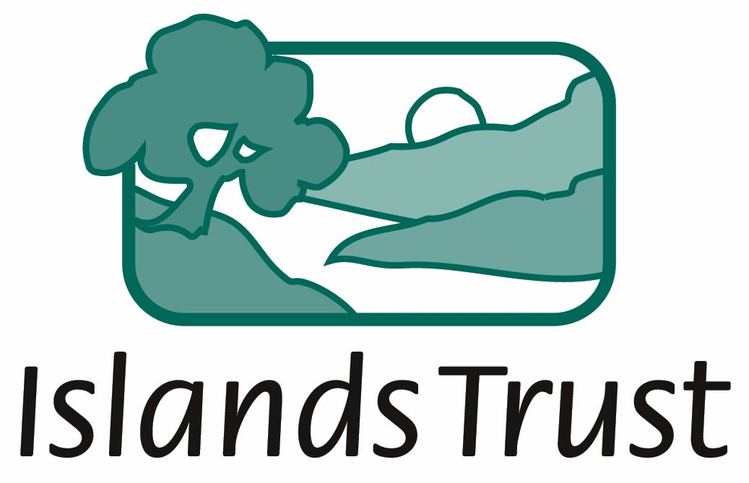 | 200-1627 Fort Street, Victoria BC V8R 1H8  Telephone (250) 405-5151 Fax (250) 405-5155  Toll Free via Enquiry BC in Vancouver 604.660-2421. Elsewhere in BC 1.800.663.7867  Email information@islandstrust.bc.ca  Web www.islandstrust.bc.ca

November 2, 2011
File No.: FG/04
Via email: mintc@tc.gc.ca

The Honourable Denis Lebel
Minister of Transport, Infrastructure and Communities
Tower C - 330 Sparks St.
Ottawa, Ontario, Canada K1A 0N5

Dear Minister Lebel:

Re: Request for information about current state of oil spill response preparedness for unconventional oils in the Salish Sea

On June 30, 2011, I wrote to you to express support for the establishment of a pilot project to undertake geographic response plans for oil spills for the Islands Trust Area on British Columbia’s West Coast. Thank you for your August 31, 2011 response. We were pleased to learn that your department sees merit in the proposal. We continue to hope that a pilot project for the West Coast assigns priority to the Salish Sea, especially given your colleague Environment Minister Peter Kent’s recent acknowledgement of the nationally important environmental values of this region.

Today, I am writing to you on behalf of Islands Trust Council to request information about the current state of oil spill response preparedness for the heavy unconventional oils (diluted bitumen and syncrude) currently being shipped in tankers from Westridge Marine Terminal in Burnaby, British Columbia.

We understand that unconventional oil products, if spilled, may pose extreme challenges for effective clean-up as they are much heavier and stickier than conventional types of oil from drilled wells. We understand that very little is known about how these products will behave in the marine environment.
Some questions our staff has suggested are important:
- Is there enough known about the fate and effects of unconventional oil in estuarine (brackish and/or sediment-laden waters) and ocean saline waters to predict how diluted bitumen or unconventional oils will behave in the Salish Sea?
- If so, is there a technical ability to track unconventional oil as it moves in the estuarine and ocean saline waters of the Salish Sea? How might this change given anticipated climate change impacts including increased storms?
- Will the products stay near the surface, suspend in the water column, or sink to the seabed?
- In the event that spilled unconventional oil sinks, what plans exist to find and remove it from the vibrant habitat on the seabed of the Salish Sea?
…/2

Bowen Denman Hornby Gabriola Galiano Gambier Lasqueti Mayne North Pender Salt Spring Saturna South Pender Thetis
The Honourable Denis Lebel
November 2, 2011
Page 2

- If submerged oil cannot be removed from the seabed, what are the expected effects of the submerged oil on the health of marine wildlife and the people who depend on them and how long are these effects expected to last?
- What will be the impacts of the condensate component of diluted bitumen?
- What are the inhalation risks from the fumes of evaporating condensate to first responders, the public and wildlife?
- Will the rapid evaporation of the condensate component of diluted bitumen delay on-water response for responder safety reasons (e.g. fire, explosion, inhalation risks)?
- Will the condensate component of diluted bitumen promote penetration of the product into coarse shore sediments and, once evaporated, leave behind the difficult-to-remove bitumen?
- Will existing spill response technology be effective at booming, skimming, and recovering unconventional oil from the water and from shore sediments of the Salish Sea?
- What research and development has been done to assess the usefulness of current response equipment to a spill of unconventional oil?
- Has a spill response gap analysis been completed to show when and where existing spill response technologies will not be effective in containing unconventional oil products? If so, does this analysis include increased storm surge scenarios?
- If effective technology exists, have response organizations invested in sufficient booms, skimmers, pumps, and beach flushing/deluge systems and waste storage suitable for handling a large spill of unconventional oil in the Salish Sea?
- Has there been an assessment of how much beach cleaning chemical application would be required along shorelines to make the weathered unconventional oil less sticky and more recoverable? What effects could use of these chemicals have on ecosystems and human health?
- Are special protocols and practices in place to ensure effective treatment of wildlife oiled by unconventional oil?
Please provide us with information about Transport Canada’s plans for assessing unconventional oil spill preparedness, and its plans to develop appropriate responses in collaboration with other federal departments, spill response organizations, the Canadian Coast Guard and industry.

Overview of Islands Trust
The Islands Trust is a federation of independent local governments that represents 25,000 people living within the Islands Trust Area. The area covers the islands and waters between the British Columbia mainland and southern Vancouver Island. It includes 13 major and more than 450 smaller islands covering 5,200 square kilometres. The Islands Trust has a legislated responsibility, through the Islands Trust Act, to cooperate with others to preserve and protect the unique environment and amenities of the Islands Trust Area, for the benefit of all British Columbians.

Policy 3.1.9 of the Islands Trust Policy Statement, approved by the British Columbia Minister of Municipal Affairs in 1994, states:

Trust Council encourages actions and programs of other government agencies which:
- place priority on the side of protection for Trust Area ecosystems when judgment must be exercised,
- protect the diversity of native species and habitats in the Trust Area, and
- prevent pollution of the air, land and fresh and marine waters of the Trust Area.

…/3

The Honourable Denis Lebel
November 2, 2011
Page 3

Under our legislated mandate, the Islands Trust Council has had an interest in marine health and oil spill issues since 1979. The Islands Trust’s concerns about marine protection naturally extend to oil spill prevention and preparedness.

Thank you for your attention to this request. We look forward to your response.

Sincerely,

Sheila Malcolmson
Chair, Islands Trust Council

cc: | Islands Trust Council  The Honourable Peter Kent, Minister of the Environment  The Honourable Keith Ashfield, Minister of Fisheries and Oceans  The Honourable Terry Lake, BC Minister of the Environment  Islands Trust Area MPs  Islands Trust Area MLAs  Islands Trust Area First Nations  Local governments around the Salish Sea including San Juan County  Marc Grégoire, Commissioner of the Canadian Coast Guard  Kevin Gardner, President, Western Canada Marine Response Corporation  Ian Anderson, President, Kinder Morgan  Stephen Brown, President, Chamber of Shipping of British Columbia  John Lewis, President, Regional Advisory Council on Oil Spill Response, Pacific Region  Islands Trust website

